**Exercise 7: Financial Forecasting**

**Scenario:**

You are developing a financial forecasting tool that predicts future values based on past data.

**IMPLEMENTATION IN ECLIPSE :**

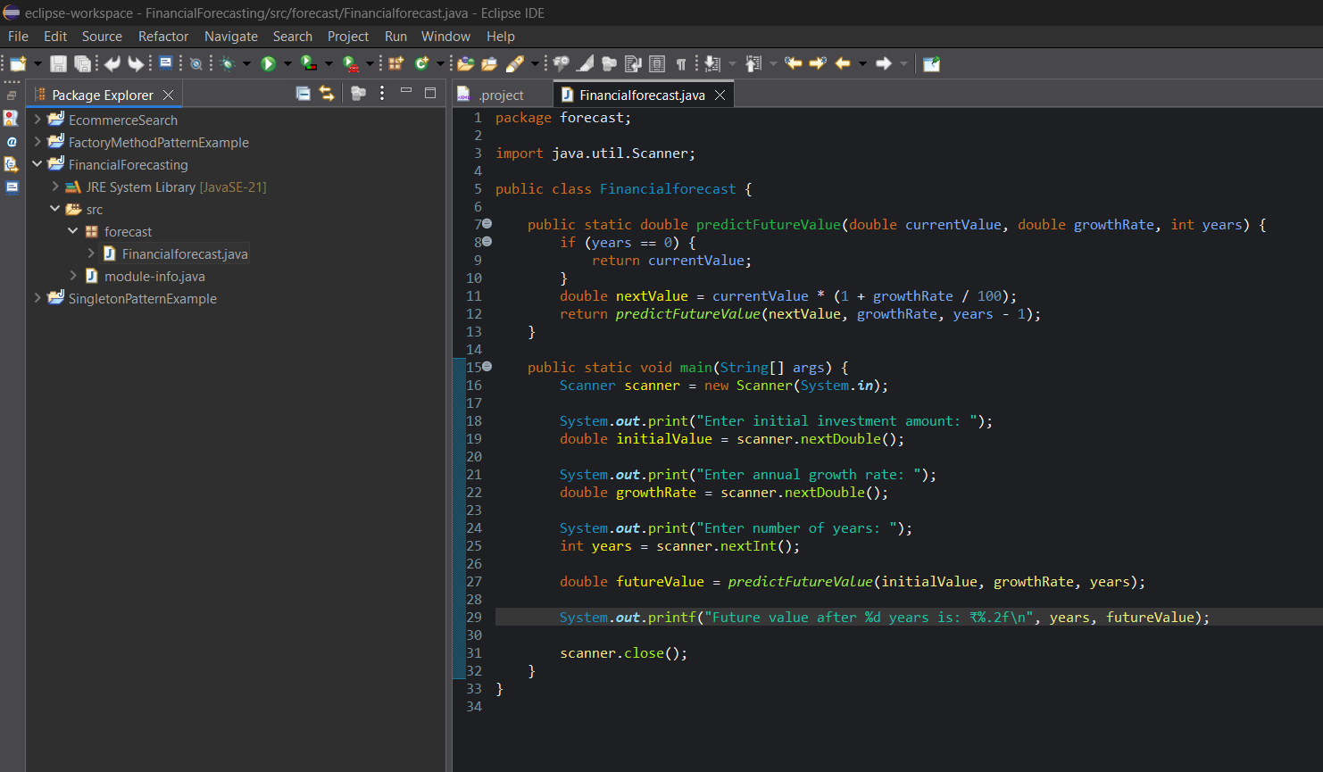

**OUTPUT :**

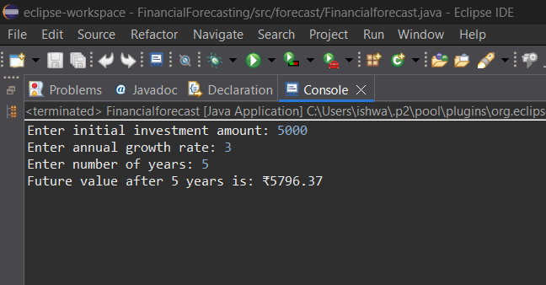

**PROGRAM :**

package forecast;

import java.util.Scanner;

public class Financialforecast {

public static double predictFutureValue(double currentValue, double growthRate, int years) {

if (years == 0) {

return currentValue;

}

double nextValue = currentValue * (1 + growthRate / 100);

return *predictFutureValue*(nextValue, growthRate, years - 1);

}

public static void main(String[] args) {

Scanner scanner = new Scanner(System.***in***);

System.***out***.print("Enter initial investment amount: ");

double initialValue = scanner.nextDouble();

System.***out***.print("Enter annual growth rate: ");

double growthRate = scanner.nextDouble();

System.***out***.print("Enter number of years: ");

int years = scanner.nextInt();

double futureValue = *predictFutureValue*(initialValue, growthRate, years);

System.***out***.printf("Future value after %d years is: ₹%.2f\n", years, futureValue);

scanner.close();

}

}

**OUTPUT :**

